Introduction

In the digital health era, online health consultation platforms have emerged as crucial tools for delivering medical advice and care remotely. These systems bridge the gap between patients and healthcare providers, especially in situations where face-to-face consultation is not feasible. This system is designed specifically for the UTM Health Centre (Pusat Kesihatan Universiti, PKU), aiming to enhance healthcare services for students and staff of Universiti Teknologi Malaysia

Background Study

This system is motivated by the findings of the study titled *"The effect of interactive factors on online health consultation review deviation"* by Wang, Y., Liang, L., Fan, W., & Zhang, X. (2022), published in *Information & Management*, Volume 59, Issue 7. The study reveals that certain interactive factors, such as frequency of interaction, message delivery style, and quality of medical information, significantly influence patients' perception of the consultation and may cause deviation in reviews. These insights emphasize the need for a system that ensures effective communication, sufficient information delivery, and continuous interaction between patients and healthcare providers.

Problem Statement

Many UTM students are unable to visit PKU for health consultations due to tight academic schedules, class commitments, or time constraints. This leads to delays in getting medical advice and untreated health issues. The increasing demand for flexible and efficient medical services at PKU highlights the need for a dedicated online consultation system that allows students and staff to consult healthcare providers without being physically present.

4.0 Proposed Solutions (include feasibility study – technical, operational, economical - CBA)

5.0 Objectives

6.0 Scope of the Project

7.0 Project Planning

7.1 Human Resource

7.2 Work Breakdown Structure (WBS)

7.3 PERT Chart (based on WBS)

7.4 Gantt Chart

8.0 Benefit and Overall Summary of Proposed System

Human Resources

The proposed system PKU UTM depends on these stakeholders, the key human resources are:

-The developmental team consists of system analysts, who are responsible for gathering requirements such as, designing the system and ensuring alignment with clinic and students needs. Software developers who are responsible for the implementation process for the system. UI and UX designers who are in charge of designing user friendly interfaces for the customers. Database administrators who are tasked to manage the storage of medical staff and patients data as well as its security.

-Campus Clinic Staff which consists of: Physicians/Doctors who will provide the medical and advice through the system. The nurses who assist in appointment scheduling. Clinic administrators who are in charge of integrating PKU UTM into the clinic and overseeing any technical issues.

-University IT Support team consisting of: Network Engineers who are responsible for ensuring systems security and connection between customers.

-End-Users who are composed of the students and faculty members, who will use the system for booking appointments, reminders and incase of emergency health alert or wellness.

-Project Management Team consisting of: Project Manager who oversee the timeline of the project by using PERT or GANTT chart and coordinate between teams. Quality Testers who test system functions before implementation.

Objectives

The purpose of developing PKU UTM consists of several objectives, such as, enhancing accessibility to provide customers with option of remote consultation for non-emergency situations such as the common cold and to allow customers to have a seamless way of book appointment online, thus reducing the wait time in the clinic. Improved communication by sending real-time notification through emails, or in UTM Smart allowing for updates on appointment, prescription and clinic announcement, and, allowing secure messaging between physicians and patients. Streamline clinic appointment by automating appointment scheduling and physicians availability thus streamline administratives workload and digitalized patients records for quick access by the clinic staff. Promoting students wellness as PKU UTM can help integrate health tips, emergency contacts and penetrative care resources into the system.

Scope

PKU UTM would cover the following functionality and limitations; The student features would include: User login through students matic card. Online booking, rescheduling and cancellation. Access to personal health records such as, allergians, vaccinations. Notification for upcoming appointment and clinic. The clinic feature would be: Physicians dashboard to view and manage appointments. Digital health record management to send or upload. Analytics to track common health issues in the campus. The technical scope would include: mobile app for both IOS and Android and web portals. Integration with the university databases for authentication. Cloud-based storage for scalability and backup. However PKU UTM would have a number of limitation which includes: Non university users who will not be able to use the system as they are not listed in university database, for critical emergency must still use direct contact outside the campus and as such integration of third parties such as external hospitals and pharmacies outside the university campus which may lead to inaccurate health records.

## **7.2 Work Breakdown Structure (WBS)**

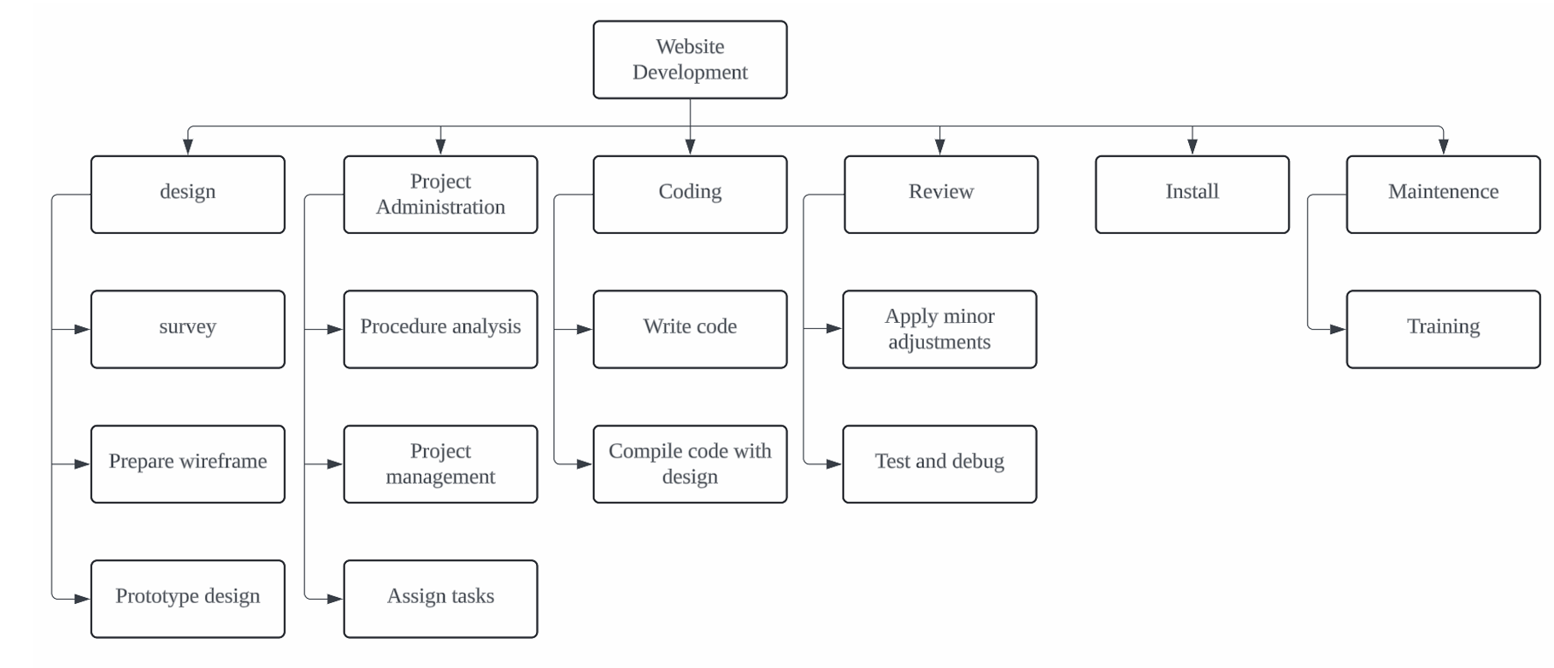

**7.3 PERT Chart**

| **Activity** | **Description** | **Predecessor** | **Duration**  **(days)** |
| --- | --- | --- | --- |
| A | Survey different types of learning and productivity website | None | 1 |
| B | Prepare wireframes | A | 2 |
| C | Design prototype | B | 5 |
| D | Analyse project procedure | C | 2 |
| E | Manage project resources and tasks | C | 3 |
| F | Assign tasks to people in charge | D, E | 1 |
| G | Write website code | F | 20 |
| H | Compile code with design prototype | B, G | 10 |
| I | Apply minor adjustments | H | 3 |
| J | Test and debug website code | I | 7 |
| K | Install software for application management | J | 2 |
| L | Provide training for new users | K | 7 |